
Student Name :_____________________

Short Exam N°1– Computer Vision 2023

½ h – No document allowed except lecture slides (graded on 15 points)

Part 1: Linear Algebra

Question 1 (2 points): which geometric transformation was applied to Image 1 to get Image 2? Same question for Images 3 to 6. Fill-in the circle corresponding to the most possible answer.

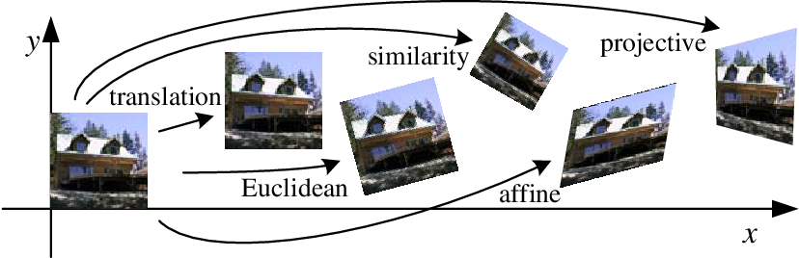
Image 2
Image 3
Image 4
Image 5
Image 6
Image 1

Input Transformation Output

Image 1 Similarity ○ Image 2 ○ Image 3 ○ Image 4 ○ Image 5 ○ Image 6
Image 1 Affine ○ Image 2 ○ Image 3 ○ Image 4 ○ Image 5 ○ Image 6
Image 1 Euclidean ○ Image 2 ○ Image 3 ○ Image 4 ○ Image 5 ○ Image 6
Image 1 Projective ○ Image 2 ○ Image 3 ○ Image 4 ○ Image 5 ○ Image 6
Image 1 Translation ○ Image 2 ○ Image 3 ○ Image 4 ○ Image 5 ○ Image 6

Question 2 (6 points): A square with corners A = (0; 0), B = (0; 1), C = (1; 0) and D = (1; 1) is transformed by a transformation T so that the new corners are A‘, B‘, C‘ and D‘. Which geometric transformation was applied to Image 1 to get Image 2? Same question for Images 3 to 6. Fill-in the circle corresponding to the most possible answer. Next, for each of these transformations give the values of parameter s, tx, ty, and θ.

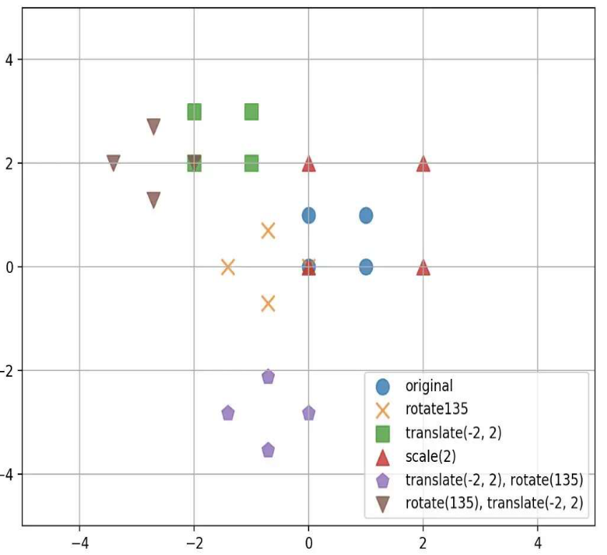 x
Image 1 – Original square shape
Image 2 – Transformation T₂
Image 3 – Transformation T₃
Image 4 – Transformation T₄
Image 5 – Transformation T₅
Image 6 – Transformation T₆


Input Transformation Output

s 0 0 1 0 tx cosθ -sinθ 0 cosθ -sinθ tx cosθ -sinθ txcosθ-tysinθ
Image 1 ○ 0 s 0 ○ 0 1 ty ○ sinθ cosθ 0 ○ sinθ cosθ ty ○ sinθ cosθ txsinθ+tycosθ Image 2
0 0 1 0 0 1 0 0 1 0 0 1 0 0 1

s 0 0 1 0 tx cosθ -sinθ 0 cosθ -sinθ tx cosθ -sinθ txcosθ-tysinθ
Image 1 ○ 0 s 0 ○ 0 1 ty ○ sinθ cosθ 0 ○ sinθ cosθ ty ○ sinθ cosθ txsinθ+tycosθ Image 3
0 0 1 0 0 1 0 0 1 0 0 1 0 0 1

s 0 0 1 0 tx cosθ -sinθ 0 cosθ -sinθ tx cosθ -sinθ txcosθ-tysinθ
Image 1 ○ 0 s 0 ○ 0 1 ty ○ sinθ cosθ 0 ○ sinθ cosθ ty ○ sinθ cosθ txsinθ+tycosθ Image 4
0 0 1 0 0 1 0 0 1 0 0 1 0 0 1

s 0 0 1 0 tx cosθ -sinθ 0 cosθ -sinθ tx cosθ -sinθ txcosθ-tysinθ
Image 1 ○ 0 s 0 ○ 0 1 ty ○ sinθ cosθ 0 ○ sinθ cosθ ty ○ sinθ cosθ txsinθ+tycosθ Image 5
0 0 1 0 0 1 0 0 1 0 0 1 0 0 1

s 0 0 1 0 tx cosθ -sinθ 0 cosθ -sinθ tx cosθ -sinθ txcosθ-tysinθ
Image 1 ○ 0 s 0 ○ 0 1 ty ○ sinθ cosθ 0 ○ sinθ cosθ ty ○ sinθ cosθ txsinθ+tycosθ Image 6
0 0 1 0 0 1 0 0 1 0 0 1 0 0 1

s tx ty θ

Transformation T2 ____ __________ ____ 135°
Transformation T3 ____ - 2 2 ____
Transformation T4 2 __________ ____ ____
Transformation T5 ____ -2 – sin(135)° 0 135°
Transformation T6 ____ - 2 2 135°

Does the transformation corresponding to a rotation * translation is commutative, ie. = translation * rotation? No, as demonstrated above

Part 2 : Let us consider the following image.

Question 1 (2 points): Why all the 2D projections (2D views) shown at right are not distorted? Ans : The most frequent parallel projections are called elevations, oblique projections and isometric projections. The elevations are just the front, top and side views of the object. Thus, the projections are given by the functions F_{front}(x,y,z)=(x,z), F_{side}(x,y,z)=(y,z); F_{top}(x,y,z)=(x,y). Applied to the house object, we get these three views. More details in https://www.math.utah.edu/~treiberg/Perspect/Perspect.htm.

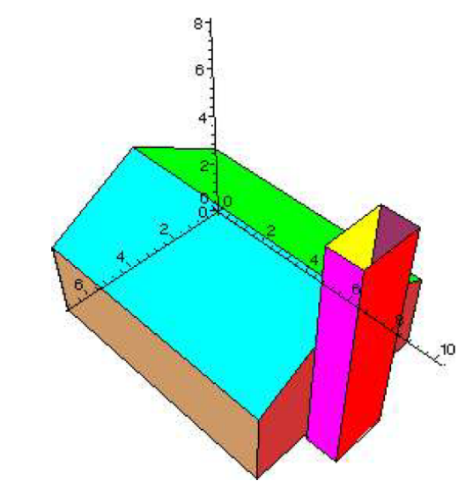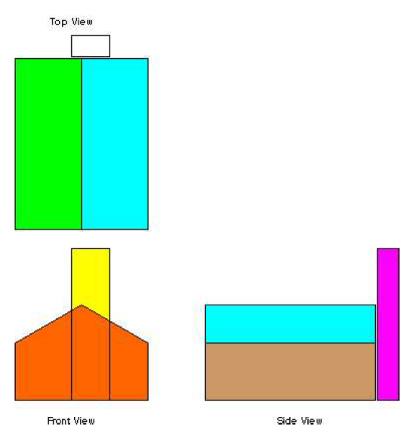
Original Image 2D projections of the original image
Question 2 (3 points): Among the following images which one/s is/are the result of an Affine projection? Ans : all, see values of the projection matrix. More details in https://www.math.utah.edu/~treiberg/Perspect/Perspect.htm.

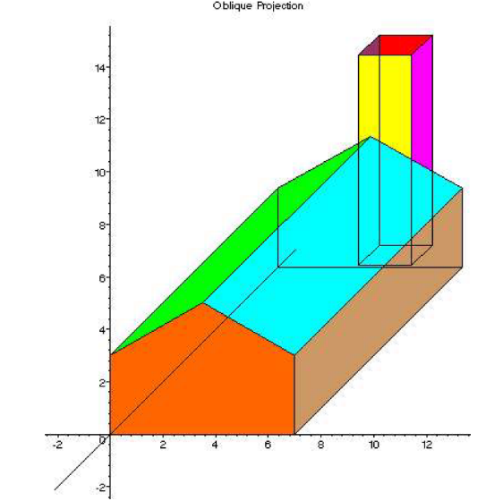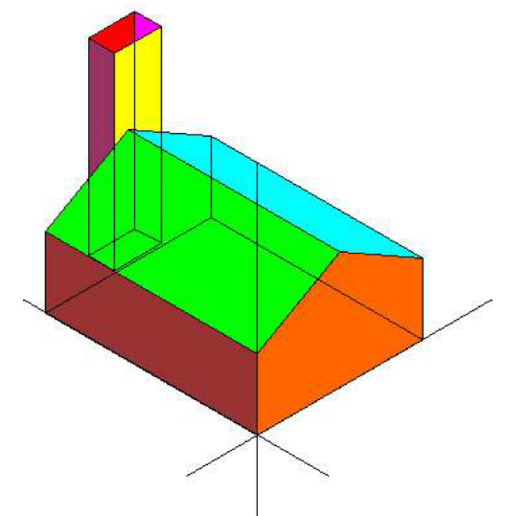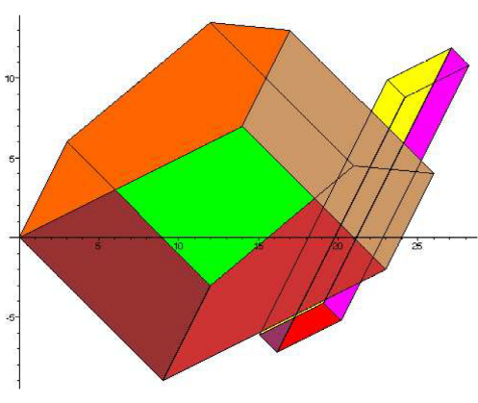

○Transformation 1 ○Transformation 2 ○Transformation 3

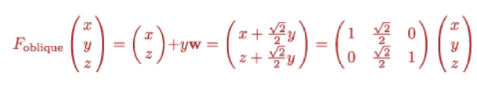 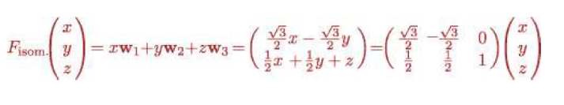 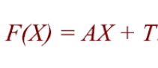 with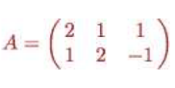and 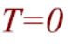

Projection applied Projection applied Projection applied
(Standard Isometric Projection)

Question 3 (2 points): How many vanishing points we have in the two following images? Draw the vanishing lines defining the location of these points. Ans. More details in https://www.math.utah.edu/~treiberg/Perspect/Perspect.htm.

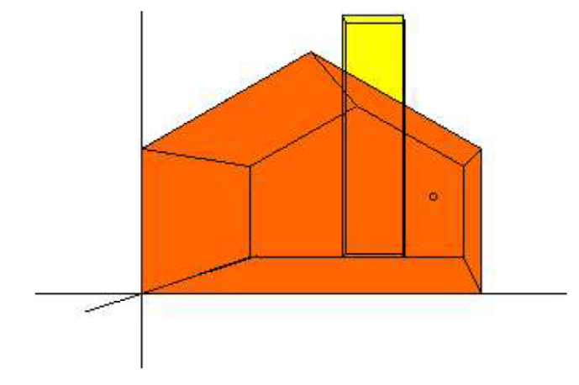
One vanishing point perspective projection

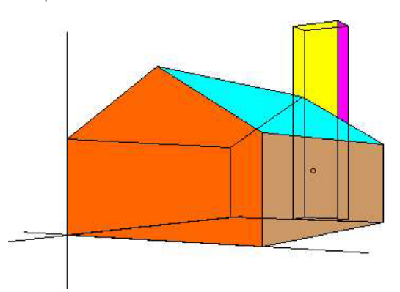
Two vanishing points perspective projection

? Examples used in this exam come from https://www.math.utah.edu/~treiberg/Perspect/Perspect.htm
In isometric projection, the plan shows the three visible sides of the object from the same angle to each other. Thus, the isometric projection shows the sides of the object at an angle of 120 to each other. Thus, these lines of the object are called isometric axes. The most common case is when measurements along the x-axis are plotted at 30°, those along the y axis at +150° and the vertical axis.

